**Abstract**

This project aims to improve anti-theft for Windows/ OS-X based laptops and ultrabooks by using different services like

SSH, sockets and QT programming. The scenario proposed in this project is totally dependent on the hardware of your laptop

like front camera, wireless support, processing capacity, GPS. Once the installation of this software is complete,

it will work in the background, it will store the current user detail and keep on checking continuously for anomalies in usage pattern, whenever it detect usage anomalies, it will take few snapshots and record a video in the background,

without taking permission of the user and then it will send a multimedia message, and number of snapshots, to our encrypted server which can be only accessed by owner using his username and password combination provided during installation of the software. Owner can also check his laptops manually using our Master software.

**Table of contents**

1. **Introduction of the Project**…………………………………………………5
   1. Project Objective.
   2. Requirement Analysis.
   3. Project Scope.

1. **Requirements**…………………………………………………………………...6
   1. Software Requirements.
   2. Hardware Requirements.
2. **Methodology**…………………………………………………………………....7-12
   1. Flow Diagram of Overall System.
   2. How it works.
3. Snapshots…………………………………………………………………………..12-19
4. **Reference and Bibliography**………………………………………………...20
   1. Books Referred
   2. Online Sources

**Introduction of the Project**

* 1. **Project Objective**

Laptops change the ways of communication, it provides an advantage of communicating with anyone virtually through video conferencing, email, etc., and it also provides a facility to store contact numbers, email id’s, in memory which reduces the concept of File-System to store personal information. Nowadays, laptops can be used to store information, documents etc., these documents can be shared with anyone through the internet. These latest laptops are very helpful for doing business work. Company related information and documents can be viewed anywhere and can be shared with anyone. Because of its open-source nature a large number of utilities has been developed for Linux and Windows system and it is getting used in many laptops. Because of its light weight and small size, it can be stolen very easily and the confidential-information of any organization or personal details of people stored in the phone memory can be easily exposed. Our project aim is to put forward a technique through which the thief, who steals any laptop installed with CyberHawk, gets captured and the user can make him/her stop misusing any confidential information. This application includes the latest technology like SSH tunneling, Socket communication, Reverse TCP where you can send video clips and photos to owner even under a firewall, unlike Email which includes only text. It gives the information about the thief by sending the snapshots and a small video clip of the thief to an alternate account, which helps us to recognize the thief.

* 1. **Requirements analysis**

One of the biggest challenges in the current Anti-theft management system is that, the exact location of crime place is not found as early it is required. Due to the delay in this procedure the crime is already done and no one people can give the correct information, because they have to face the police investigation. The latest ultrabooks provide lots of capabilities and in addition it provides different kinds of application which are used to store lots of information in an organized form. Because laptops are getting lighter in weight day-to-day, there is a lot of chance to misplace/ forget it somewhere and also anyone can steal it without your knowledge. It contains lots of confidential documents, data and personal information which will be in danger. So it is important to find the thief, all the existing applications could not be able to identify the thief, it is only capable of locating the device. Mobile anti-theft system is a project which helps us to track the location of the smartphone. Position tracker works on Global Positioning System(GPS). When requested MATS will fetch latitude and longitude satellites and send it as a Email but this information is not enough so it is difficult to identify the thief by using this information. Many software based on anti-theft have been developed, but most of these software is not free of cost. It is difficult to identify the thief by using this software. The Existing anti-theft system do not get perfect information of the thief. In most of the cases, the innocent is accused in the existing system. The existing system is criticized for being inefficient, time consuming, poorly managed, and lacking. The major goals of

this system are:

1. It is user- friendly and easy to use.
2. Track the location of the laptop.
3. Automatically send Email whenever usage pattern is changed.
4. Recover the lost laptops.
5. Identify the thief who had stolen the laptop.
   1. **Project Scope**

# The current system is developed which run in Desktop PC, Laptop. In future we can develop it in

# Mobile applications like; Android, Windows Phone, etc.

**REQUIREMENTS**

## **Software Requirements**

* Windows 7 or later
* Python 3.x
* MariaDB 7.0 or later
* Apache Server

## **Hardware Requirements**

* Hard Disk – 2 GB
* RAM – 1 GB

**Methodology**

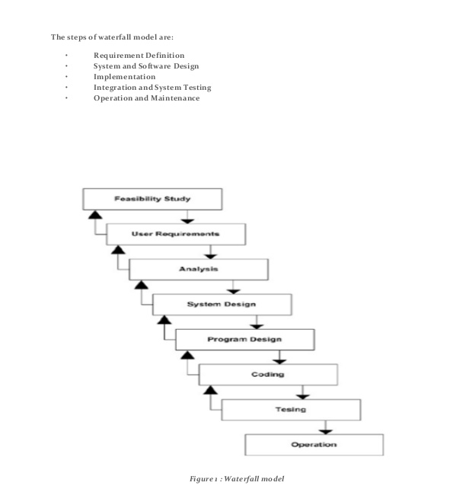

**System Analysis**

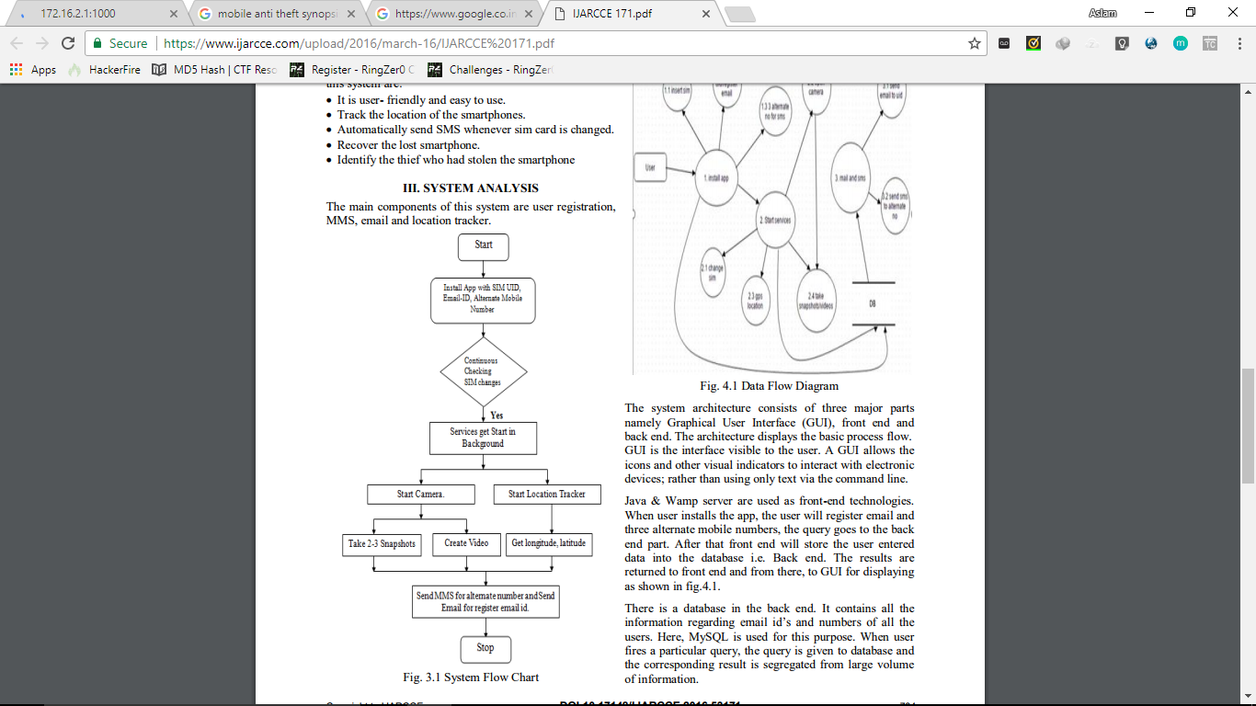

**System Architecture**

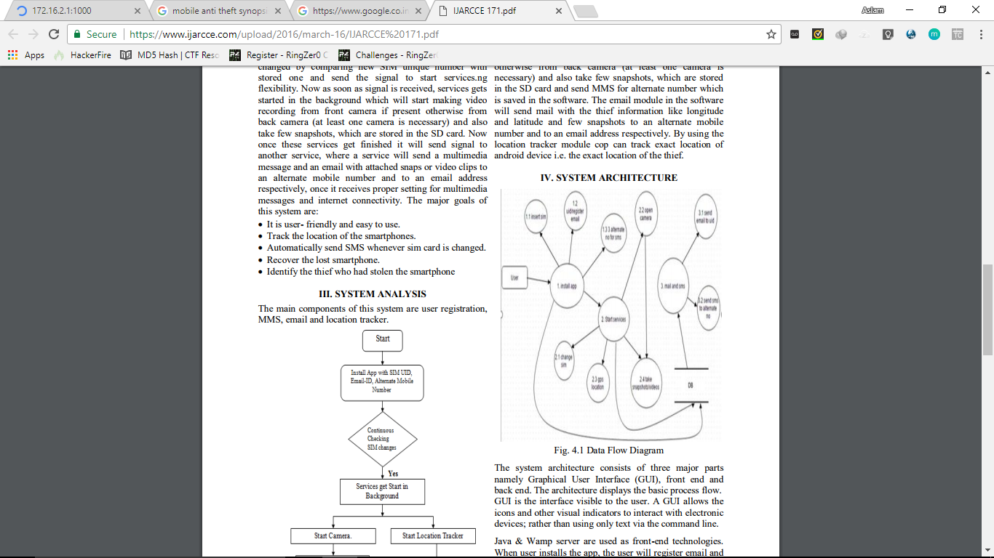

The system architecture consists of three major parts namely Graphical User Interface (GUI), front end and back end. The architecture displays the basic process flow. GUI is the interface visible to the user. A GUI allows the icons and other visual indicators to interact with electronic devices; rather than using only text via the command line. Python & Wamp server are used as front-end technologies. When user installs the app, the user will register email and three alternate mobile numbers, the query goes to the back end part. After that front end will store the user entered data into the database i.e. Back end. The results are returned to front end and from there, to GUI for displaying as shown. There is a database in the back end. It contains all the information regarding email id’s and numbers of all the users. Here, MySQL is used for this purpose. When user fires a particular query, the query is given to database and the corresponding result is segregated from large volume of information.

**Advantages**

This software is freely available.

• The main advantage of this application is anyone can use it without having much knowledge about the device.

• The application meets user’s immediate and long term requirements by providing the images and videos of the thief.

• Easy for the user to identify the thief and make him/her get caught and arrested.

• This application provides the information about the location of the android based smart phone with the help of e-mail.

The developed anti-theft app will enable user to use his android based smartphone with freedom of getting stolen. It will enhance the security of the android based smartphone.

**Disadvantages:**

* Requires Hi-Speed Internet Connection
* Kernel level access in Linux systems
* Firewall should allow traffic in port 56890
* Higher CPU cycles

**Snapshots**

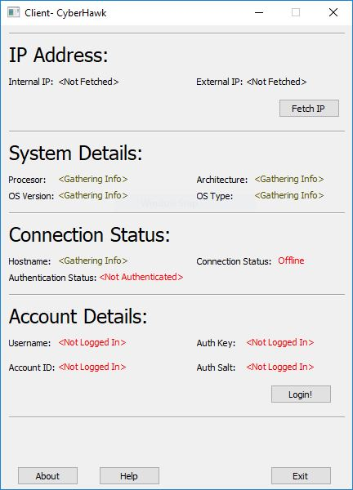

**Client**

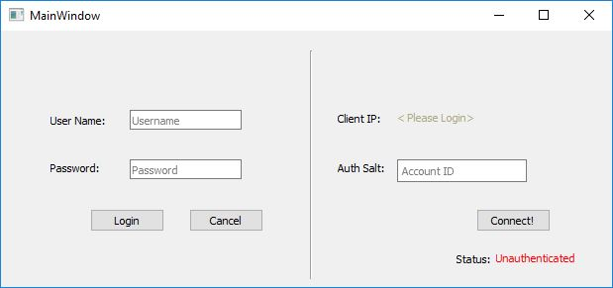

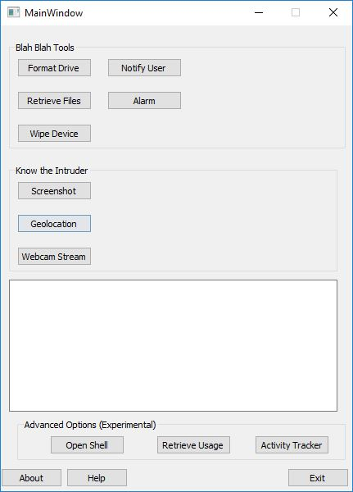

**References:-**

1. Book : Blackhat Python.
2. Book : Introduction to socket programming in Pythonby Jason Gilmore
3. [www. nostarchpress.com](http://www.programmer2programmer.net/)
4. [www. Intellij.community.com](http://www.readymadeproject.coom/)
5. <http://ajprofessionals.googlepages.com/>
6. [www.wikipedia.org](http://www.wikipedia.org/)